Reviewed 2/23/2021

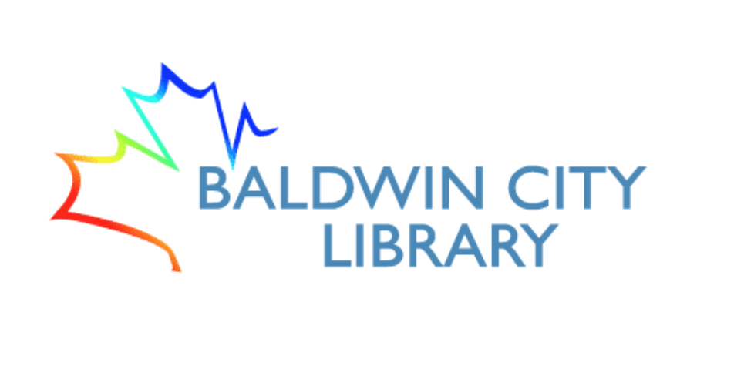

**Technology Development**

**3-5 Year Plan**

**Our Vision**

The Baldwin City Library provides library resources, services and programs as a gateway to information that support and enhance lifelong learning, personal leisure, and the community’s quality of life.

Our strategic areas of focus: Literacy, Lifelong Learning, Community Engagement, and Local History & Genealogy.

**Technological Literacy**

Technological literacy, the ability to use technology to effectively access information, communicate, and create, is critical to lifelong learning, community engagement, and quality of life. School resources, job information, news, and multitudinous other resources and information are online--in fact there are numerous resources, data, and information that can *only* be discovered online. Technological literacy is essential for education, the economy, and social connectivity--which are all related to the health, affluence, and the success of a community.

At the Baldwin City Library it is our goal that all residents of our community are confident users of technology and consumers of information.

**Current Resources & Activities**

8 public access computers with internet access & Microsoft Office

2 AWE Early Literacy computer stations

12 Hotspots with T-Mobile Service for check out (grant funded--expires in 2022)

10 Chromebooks for check out

2 Circulation Desk computers

4 Staff Use Computers

1 Staff Use Laptop

1 Microfilm Reader

1 Flatbed Scanner for patron use

1 Copier/Printer in staff workroom

1 Copier in the Circ Desk area for patron copying

**Goal 1:** Improve patron access computers

All eight of our patron access computers are over five years old. Our goal is to replace two computers a year over the next four years. Depending on other equipment needs that arise, we may be able to do this with our current Equipment Purchase budget category. If we’re unable to meet the replacement schedule with the Equipment Purchase budget, we will seek grants for computer updates.

**Goal 2:** Increase staff training

Staff training in G Suite applications and concentrated Koha/Next training are priorities. Digital resources training for literacy, lifelong learning, local history, and social media use are also staff training needs. Increase training in use of electronic resources available through the State Library (databases, eBooks, audiobooks, etc.), and Next (Hoopla, Flipster). All these areas of training will benefit both staff in their roles and job tasks and be passed on to patrons to increase technological literacy.

**Goal 3:** Increase technology-related programming

Offer ‘Welcome to Tech,’ or other basic, introductory courses for patrons of any age. Establish basic tech help walk in hours where patrons can bring in devices and ask questions. Offer learn-to-code opportunities for children and teens. Provide both passive and active technology training opportunities.

**Action Steps:**

* Increase number of patrons with Kansas State Library cards.
* Hardware, software, and other purchases will be made in consultation with NEKLS technology specialists and support staff to ensure high quality and usability.
* Programming goals set in collaboration with Programming Librarian and coordinated with the library’s overall activity calendar.
* Continue to work with municipal government to secure adequate funding to ensure technology equipment purchases and maintenance/replacement. Work with Friends of the library and seek grant funding to help fill the gaps.
* Secure or increase funding so hotspots can be continued after CARES grant funding expires.
* Work with Patron Services Librarian and Programming Librarian to monitor technology trends and introduce patrons to the latest applications and resources through programming.